PHASE -1

PROBLEM STATEMENT AND DESIGN THINKING

|  |  |
| --- | --- |
| DATE | 28 September 2023 |
| GROUP ID | 4 |
| PROJECT NAME | FAKE NEWS DETECTION |
| MAXIMUM MARK |  |

ABSTRACT:

I found a research paper titled “Fake News Detection using NLP” published in the 2023 International Conference on Innovative Data Communication Technologies and Application (ICIDCA). The study proposes a machine learning approach for detecting fake learning algorithms to evaluate the content and aesthetic components of news stories. The proposed model was analyzed using a large dataset of real and fake news articles, and it outperformed many existing systems. The paper is available on IEEE Xplore. Another research paper titled “Fake News Detection Using Machine

Learning Ensemble Methods” explores different textual properties that can be used to

distinguish fake contents from real. The authors trained a combination of different machine

learning algorithms using various ensemble methods and evaluated their performance on four

real-world datasets. You can find this paper on Hindawi.

If you are interested in learning more about fake news detection, you might also find the

following resources helpful &quot;A Survey on Natural Language Processing for Fake News Detection&quot; &quot;Fake News detection Using Machine Learning&quot;

Problem definition

Fake news detection using Natural Language Processing (NLP) is a **practical problem** that aims to identify whether a given piece of news is fake or real. [It involves analyzing text-based news and building a machine learning model to classify news articles as authentic or fake](https://www.analyticsvidhya.com/blog/2021/07/detecting-fake-news-with-natural-language-processing/)[1](https://www.analyticsvidhya.com/blog/2021/07/detecting-fake-news-with-natural-language-processing/" \t "_blank).

[To detect fake news, one can use various techniques based on style and content](https://www.analyticsvidhya.com/blog/2021/07/detecting-fake-news-with-natural-language-processing/" \t "_blank)[1](https://www.analyticsvidhya.com/blog/2021/07/detecting-fake-news-with-natural-language-processing/" \t "_blank). [Some approaches rely on analyzing the writing style, including factors such as spelling errors, punctuation, vocabulary, and grammaticality](https://www.analyticsvidhya.com/blog/2021/07/detecting-fake-news-with-natural-language-processing/" \t "_blank)[1](https://www.analyticsvidhya.com/blog/2021/07/detecting-fake-news-with-natural-language-processing/" \t "_blank). [Others focus on fact-checking and comparing the content of news articles with reliable sources](https://www.analyticsvidhya.com/blog/2021/07/detecting-fake-news-with-natural-language-processing/).

[One common approach is to use](https://www.analyticsvidhya.com/blog/2021/07/detecting-fake-news-with-natural-language-processing/" \t "_blank) **[TF-IDF vectorization](https://www.analyticsvidhya.com/blog/2021/07/detecting-fake-news-with-natural-language-processing/" \t "_blank)** [to represent the text data and then apply machine learning algorithms for classification](https://www.analyticsvidhya.com/blog/2021/07/detecting-fake-news-with-natural-language-processing/" \t "_blank). [The TF-IDF vectorizer calculates the importance of each word in a document by considering its frequency in the document and its rarity across the entire corpus](https://www.analyticsvidhya.com/blog/2021/07/detecting-fake-news-with-natural-language-processing/" \t "_blank). [By training a classifier on labeled data, it becomes possible to predict whether a new piece of news is fake or real](https://www.analyticsvidhya.com/blog/2021/07/detecting-fake-news-with-natural-language-processing/" \t "_blank).

[If you are interested in working on this problem, you can start by collecting a dataset of labeled news articles and exploring existing research papers and projects on fake news detection using NLP](https://www.analyticsvidhya.com/blog/2021/07/detecting-fake-news-with-natural-language-processing/" \t "_blank).

DESIGN THINKING

Design thinking is an extension of innovation that allows you to design solutions for end users with a single problem statement in mind. It not only imparts valuable skills but can help advance your career. It's also a collaborative endeavor that can only be mastered through practice with peers

EMPATHY MAP

An empathy map is a collaborative visualization used to articulate what we know about a particular type of user. It externalizes knowledge about users in order to

1. create a shared understanding of user needs,
2. 2) aid in decision making. This article is a guide to empathy mapping and its uses.

EMPATHYMAP: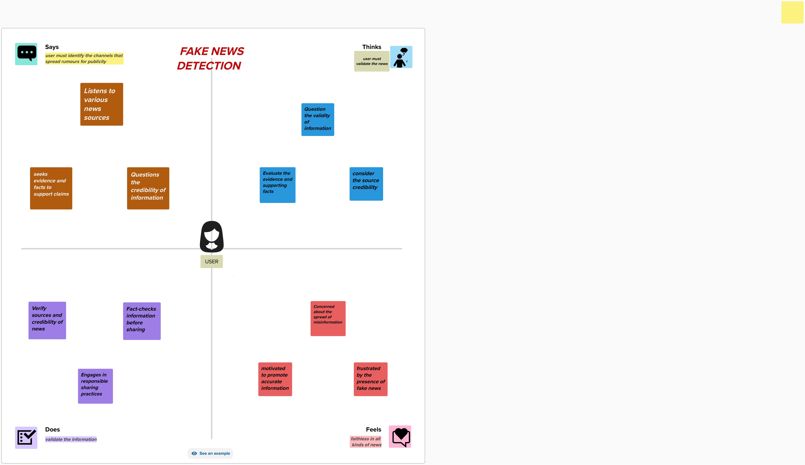

BRAINSTORM:

Brainstorming is a group problem-solving method that involves the spontaneous contribution of creative ideas and solutions. This technique requires intensive, freewheeling discussion in which every member of the group is encouraged to think aloud and suggest as many ideas as possible based on their diverse knowledge.





